# 2022 Overview

We sampled 30 locations around Mývatn in a similar manner to 2021. Sampling in 2022 was on 30 May and 1 June. Sampling in 2021 was on 6-7 August and during a bloom (although it was waning at the time). One of our hopes in comparing these two periods was to compare how nutrients were structured in early summer vs late summer (and thus before and during a bloom). I will briefly cover some very preliminary looks at the data. There’s a lot more to be done here, but I hope that this document will help inform how to deal with nutrient samples from this summer.

## Sampling Sites

I generally treated locations as separate sites across years, although we aimed to be near locations used in 2021. Points were, therefore, quite near 2021 (distance = 20 ± 21, mean ± sd). There was one point that was fairly far (120 m), but beyond that all points are within 50m across years.

## General Characteristics

### Depth

The sites were quite similar across years.

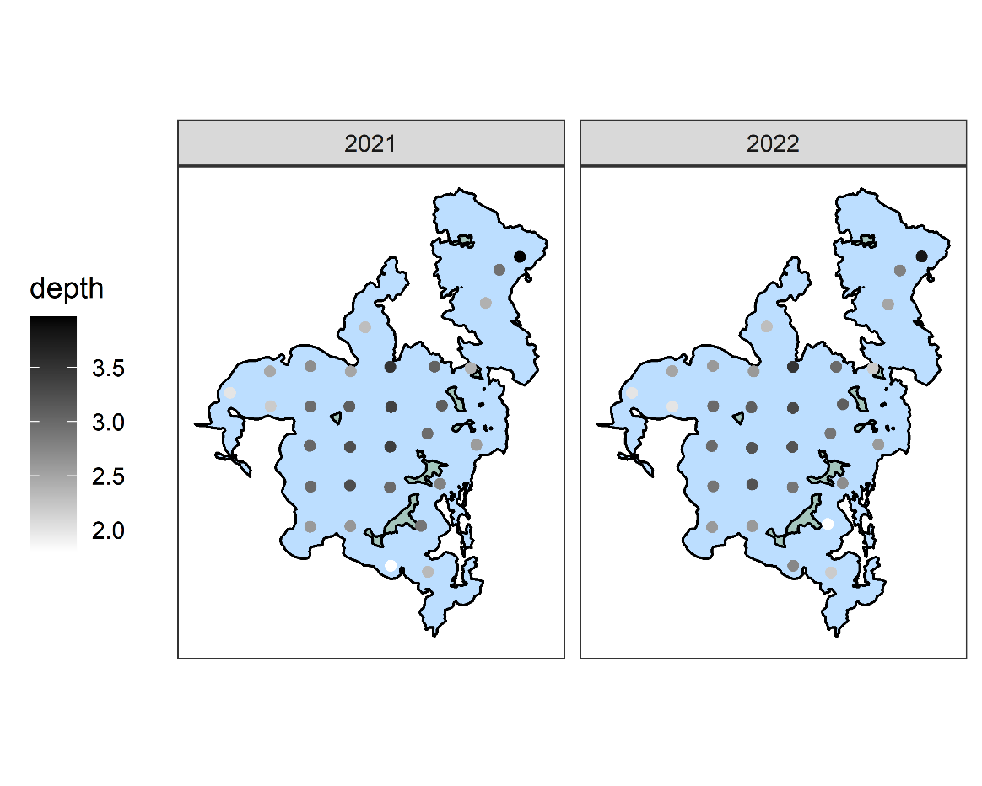

Sites in 2021 had min depth of 1.8, median of 2.98 and max of 3.97 m. Sites in 2022 had a min depth of 1.8, median of 2.75 and max of 3.8 m. There was a fairly strong correlation (r2 = 0.67).

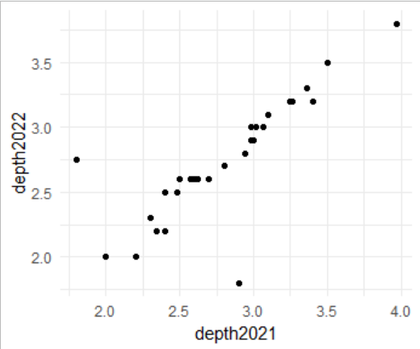

### Sediment Type

As in 2021, we recorded the “sediment type” which was defined as what the surface cover appeared to be in the two cores. Despite being quite close, there was some variation in sediment type across years. This is probably attributable to small scale heterogeneity in benthic communities. We ended up in slightly more “macrophyte-dominated” sediments (6 in 2022 as compared to 3 in 2021). As in 2021, midge tubes were not prevalent enough to be a sediment type. Map

### Temperature

Surprisingly, water temperatures (taken at 50 cm below the surface) were very warm in both years. The water was colder in 2022 (mean = 12.4 as compared to 15.3 in 2021).

## Biological Information

### Phytoplankton

Secchi depths were much deeper in 2022 than 2021, consistent with the absence of a cyanobacteria bloom. I coded depths of 4 for when the secchi was visible on the bottom in the scatterplot.

Consistent with secchi depths, chlorophyll and phycocyanin concentrations in the water column were lower in 2022 than 2021. We did see some chlorophyll towards the western side of the lake. However, there was still chlorophyll in the water column (see histogram below) and most sites had phycocyanin readings of 1.

We also measured dissolved oxygen at 0.5 m from the surface and the nearest 0.5m to the benthos. We did not do full profiles this year because it was too slow, given that Riley and I were doing everything alone. DO concentrations were higher in 2022, due to lower temperatures.

Like Amanda’s 2021 paper would suggest, we do see evidence for benthic dominated production. There are generally positive slopes in DO with depth, especially in 2022.

Comparing the ratio of dissolved oxygen concentration between the surface and benthos provides a rough measure of autotrophic structure. Nearly all sites had higher benthic concentrations than pelagic. While we found more variation in 2021.

### Midges

As in 2021, we found very few (but not no) midges. Notably, we found fewer Chironomini and more Tanypodinae. This may be due to the Chironomini emergence, but I don’t have an explanation for the relative increase in Tanypodinae abundances.

There were two Tanyrarsini in 2022. We confirmed that the one in the southeastern part of the lake was *T. gracilentus* by mounting it.

Given the above, midge communities were quite different across years (colors as in the above plot).

### Benthic Algal Communities

We measured benthic algal community composition using the benthotorch on the sediment surface. This core was previously used for nutrients, so nutrients and algae are paired at the core level. Midges were taken from a separate core.

As in 2021, benthic algal composition is dominated by diatoms. Thinking I saw spatial patterns in the data, I fit an overly complicated GLS model to the data across the two years. The response variable was the ratio of cyanobacteria to diatoms in the sediment and I included linear east to west and north to south gradients, sediment type (either cladophora or not), year (as a factor), and the interactions between the spatial gradients and year. I accounted for spatial autocorrelation in the residuals. It yielded several interesting insights: cladophorales has a much higher proportion of cyanobacteria pigments (p = 0.0002). There were no consistent linear spatial patterns, but there was evidence that there was comparatively more cyanobacteria in the eastern sediment in 2022 (p = 0.0286) and in the south (p = 0.0254).

There still isn’t strong evidence for an association between pelagic cyanobacteria (as measured by the benthotorch on whatman filters) in August 2021 and benthic surface cyanobacteria concentrations.

# 2021 Nutrient Analyses

We sent samples from 30 locations on the lake sampled on August 6th and 7th to ALS in Denmark to analyze nutrient concentrations. The analytes we received data for were: Ammonium and ammonia, Nitrite, Nitrate, Total Phosphorous, Orthophosphate, and Total Nitrogen. Methods given by ALS are as follows:

|  |  |  |
| --- | --- | --- |
| Original Name | Method | Interpreted name |
| Ammonium+ammoniak-N, Filt Felt | DS/ISO 15923-1:2013+DS224:1975Mod | Annomium and ammonia |
| Nitrit kvælstof, NO2-N, Filt felt | DS/ISO 15923-1:2013 | NO2 |
| Nitrat Kvælstof, NO3-N, filt felt | DS 223:1991,automatiseret bestemmelse | NO3 |
| Total phosphor P, Filt Felt | DS/EN ISO 6878 Del 7:2004 + DS/EN ISO 15681-2:2018 | Total P |
| Orthophosphat-P, Filt Felt | DS/ISO 15923-1:2013 | Orthophosphate |
| Total kvælstof, N Filt Felt | DS/EN ISO 11905-1:1998 | Total N |

Pelagic samples were taken from integrated water columns (from the surface to the deepest full m). Benthic samples were collected from the top 3.5 cm of the sediment using a syringe taken from the surface (using the extended syringe). All samples were filtered through 0.45 μm filters and placed directly into a cooler on ice. These were transferred immediately to a frost-free freezer upon our return.

The data show fascinating spatial patterns; below are maps first of the concentration (mg/L) on a log10 scale. All the samples were able to be analyzed and concentrations were mostly above detection limit, except for nitrate in the water column.

And Z scored within layer and analyte:

Using these quantities, we also generated dissolved organic N, total inorganic N, dissolved organic P, and N:P ratios (these are total N: total P).

Probably because the masses reported for ammonium, phosphate etc. may include things other than N (e.g., oxygen and hydrogen), there are some negative DONs and DOPs (I just subtracted the inorganics from the totals). If that’s true it would just be a linear adjustment. This could also be the result of measurement error.

Riley and I have played around a little with some very preliminary analyses of the data. We had a few initial questions that we have looked at so far: 1) Is there any relationship between nutrient concentrations in the benthos and pelagic zone? 2) Is there any evidence of an east-west nutrient gradient? 3) Is there any relationship between nutrient concentrations (either pelagic or benthic) and measurements of phytoplankton or epipelic algae? And 4) Is there any relationship between nutrient concentrations and midges? There are many other interesting things to explore here, and we’ve only really scratched the surface addressing these questions.

## Some methodological considerations

Generally, nutrients appear correlated. For some pairs this makes total sense; it’s unsurprising that phosphate is correlated with tp, for example. I am surprised to see how correlated P and N are in the sediment. At first, I was concerned this was evidence of a methodological issue, but not all analytes are correlated (nothing with NO3), which is perhaps evidence that biology could be driving things. It’s also quite interesting that the N:P ratio is somewhat negatively correlated to ammonium in the sediment and unrelated to TN, despite being a product of it.

For analyses, I set all concentrations below detection limit at 0. I fit all the models using REML including spatial autocorrelation using an exponential correlation structure. However, many variables show high spatial heterogeneity at small spatial scales (high nuggets) and nonsensical ranges (< 1000m). Additionally, I perform many hypothesis tests. We expect that ~5% should be significant at the 0.05 significance level by chance. We could adjust using a correction, but I have not done that here. Therefore, results should be treated with caution. These are intended to be quick and dirty looks at the data.

The sediment types differ in the structure of the sediment, which may influence benthic nutrient concentrations. Riley noticed that some more compact sediment had clearer interstitial waters during our sampling this summer. There are few sediment types other than the soft sediment (5 others total), so it may be difficult to estimate an effect even if there is one. Because sediment types are not evenly distributed over space, this is especially tricky. Indeed, GLS models with sediment type as the only predictor found no evidence that sediment type influences benthic nutrient concentrations (all pvalues >0.1 except for perhaps a negative effect of sediment on benthic dissolved organic N p = 0.054, relative to the other sediment types). Unless specified, I haven’t in the following analysis.

There is also the possibility that sample depth influenced our measured pelagic concentrations. I checked this by fitting a GLS model (accounting for spatial autocorrelation) to the lake depth and my best guess at the sample depth (i.e., floor(depth-0.05), I subtracted 5 cm from the depth because I assumed you can’t get a clean Schindler nearer to the bottom than that). There was no strong evidence that nutrients were related to the actual depth of the sites, except for ammonium which had a slightly significant trend (p = 0.035). However, this is really complicated. The result is very sensitive to how deep you assume the Schindler could have been taken. There are some high values of ammonium and TN from sites that were very close to the nearest m (either at or within a few cm), which could be due to disturbing the sediment. These values are not obviously elevated for any other analytes. I haven’t adjusted for this in my subsequent analyses, but it probably should be done.

## Relationship between benthic and pelagic nutrient concentrations

There is not a strong apparent relationship between benthic and pelagic nutrients of any type.

Below are plots of the ratio of pelagic to benthic nutrients (pelagic concentration/benthic concentration). Unsurprisingly most are higher in the benthos (ratio of less than 1), except for the N:P ratio. The pelagic zone tends to have a higher N:P ratio compared to the benthos. There are possibly some spatial gradients (see maps, triangles indicate pelagic concentration higher than benthic). I’ll examine this in the next section.

## Spatial Nutrient Gradients

I fit GLS models to the nutrient concentrations with two explanatory variables: the number of km east starting at the westernmost point in the lake and the number of km north starting at the southernmost part of the lake. I find it helpful to refer to the figure below for a visual of that while interpreting estimates.

Few of the benthic models had ranges greater than 1,000 (only DON and N:P ratios), while most pelagic models had predictably higher ranges.

We found some evidence for north-south and east-west gradients in nutrients. Interstitial ammonium, nitrite, and total inorganic N were higher on the eastern side of the lake (i.e., positive eaststd term, p = 0.0169, 0.0197, 0.0144, respectively). Interstitial TN also was higher in the north (p = 0.0357). Pelagic concentrations of nitrite and total P were highest in the south (p = 0.017, 0.000007, respectively). N:P ratios were higher in the northern part of the lake (p= 0.0176). The ratio between pelagic and benthic concentrations only found the north south gradient, relatively less pelagic P in the north (p = 0.01).

## Relationship between nutrient concentrations and algae

Community analyses of these data may be promising, but they will take more care than I give here, but I really just explore the patterns here.

### Leaky Anabaena

One thing Riley and I looked at was whether there was evidence of an association between water column phycocyanin concentrations and pelagic dissolved organic N. We found a positive correlation (p = 0.0071). I’m a little concerned about leverage (few low phycocyanin values driving down the slope).

### Pelagic Nutrients and phytoplankton composition

Riley and I were quite interested in seeing whether pelagic nutrients were related to composition. I just looked at this using the turner probes, but one could do it using the benthotorch readings on whatman filters (see Measurements of Phytoplankton in the 2021 Overview).

There is perhaps a negative association between pelagic N and the amount of chlorophyll relative to phycocyanin. However, there was no statistical support for this. While it does seem unrelated largely to P, I did find some significant correlations. These were likely spurious as the slope was positive, driven by a few high values.

There was no evidence for interstitial nutrients interacting with phytoplankton composition.

### Benthic Nutrients and epipelic algal composition

I don’t see tons of patterns here and neither do simple GLS models with the nutrient as the explanatory variable and the ratio of benthic cyanos to diatoms as the response.

## Relationship between interstitial nutrient concentrations and midges

This may be more interesting in a year when midges are abundant. However, we do have some Chironomini (up to 8 per core). In other lakes, people would say that those are moderate densities (~4,000 ind m-2). The densities are low for Mývatn. Additionally, cores for nutrients and midges were separate. Therefore, this analysis only works if we assume chiro densities are somewhat spatially autocorrelated at small spatial scales (i.e., within 1m).

Our GLS models (conc~chiro, accounting for spatial autocorrelation) found that Chironomini may have a positive effect on DON (p = 0.0001) and there is weak evidence that they increase nitrate (p = 0.0175). Although, I am more skeptical of this latter effect, looking at the above plots.

# Below are My Initial Notes from 8 September 2021

These cover where the sites are and sampling schemes for midges, water samples, turner probes, and some zooplankton. I have left them unedited.

# 2021 Overview

On August 6th and 7th 2021, we sampled benthic and pelagic characteristics at a roughly 1 km grid around Lake Mývatn. Points occasionally had to be adjusted to avoid shallow areas or areas that could not be cored in due to rocks. This yielded 30 locations (Fig. 1). Most sites were around 1 km from each other, but the two northernmost were only 610 m away from each other. The furthest Euclidian distance was 8.6 km between the site in Álftavogur and the northernmost site in the north basin.

## General Characteristics

### Depth

We measured depth at each site. Our shallowest site was 1.8 m and our deepest was 3.97 (in the mined area of the north basin). The median depth was 2.92 m. Generally, the sites in the center of the main basin are deeper than those around the edges.

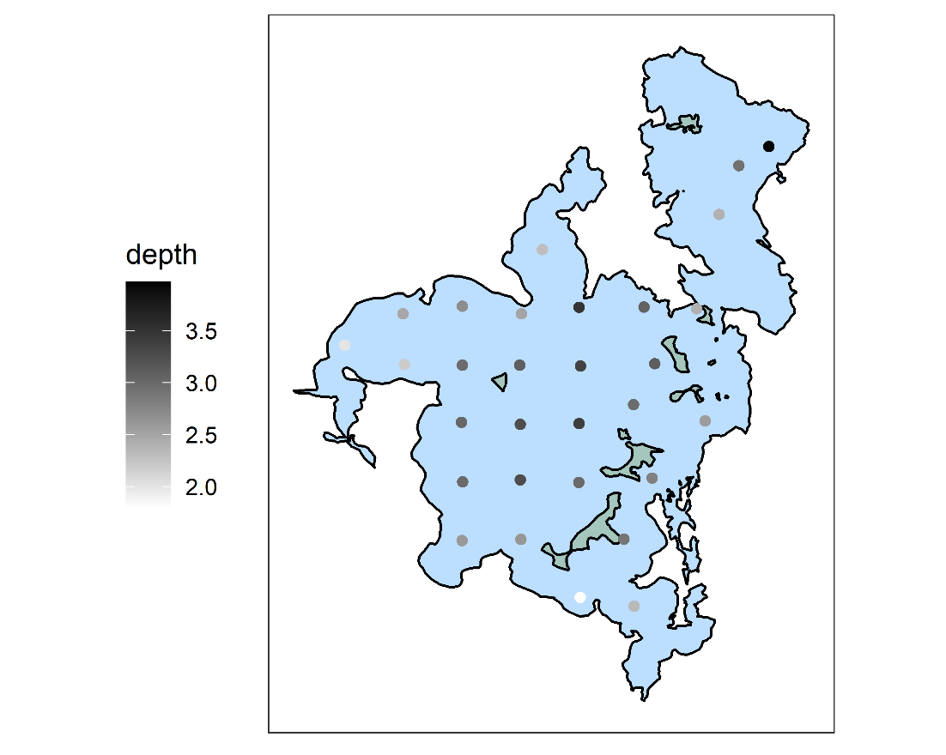

### Sediment Type

At each site we took to Kajak cores. We first visually characterized the surface of the benthos as either soft sediment, macrophyte, Cladophora mat, or midge tubes. No site fell into this last category.

### Temperature

Temperature was high for both days. Our measured water temperature was likely more driven by when within a day we sampled the location than meaningful differences in water temperature.

## Biological Information

### Measurements of Phytoplankton

#### Secchi Depth

We estimated phytoplankton biomass using several metrics. The simplest metric we used was the secchi depth. This roughly describes the amount of material in the water column. There was minimal wind leading up to this sampling event, so the material in the water is most likely attributed to the phytoplankton biomass (rather than suspended sediment). A low secchi depth indicates lots of phytoplankton. The lowest secchi depth was in Álftavogur (0.8) and the secchi disk could be seen at the bottom of the lake near the cold springs south of the Kálfaströnd peninsula.

The median secchi depth was 1.83 m (after removing the site by the cold springs). I was surprised visibility was so low in the eastern side of the lake.

#### Turner Handheld probes

At each location, we took two samples of water from each meter between the surface and benthos using the modified Schindler trap. We first took three measurements of chlorophyll and phycocyanin using the turner fluorosense probes. These are in “Turner units” and are not comparable between the pigment types. However, we do have a conversion to convert the phycocyanin to units that would have been read by Árni’s algae torch.

The chlorophyll readings are not related to the phycocyanin readings at the same location (adjusted r2=0.079, p = 0.073). Interestingly, the patterns are similar, but not identical to the secchi depth.

#### BenthoTorch readings on Whatman filters

We filtered 300 mL of water from each site through GF/f Whatman filters. These were frozen and will be measured on a spectrometer by Phil’s group to pair with the AVARIS flight. Before freezing them, we took a benthotorch reading on the surface of the filters. This gave us approximate composition of the pelagic community in units of chlorophyll a per cm2. The probe separates greens, cyanobacteria, and diatoms. The resulting communities can be seen in these scatterplots. The size of the pies is the total units of chlorophyll added across the three taxa.

The cyanobacteria were generally the most abundant taxon, while diatoms were uncommon. Diatoms appeared more common in the north basin. This may be associated with methane (?) bubbles suspending sediment. We saw several places that had bubbles and lake balls.

There was no evidence that cyanobacteria and greens were related (p = 0.136).

### Vertical Changes in Dissolved Oxygen

At each of the sites, we did temperature and DO profiles. In general, temperature decreased with depth. There were some sites where dissolved oxygen increased with depth and others where it decreased. There were also some sites where the two had a nonlinear relationship.

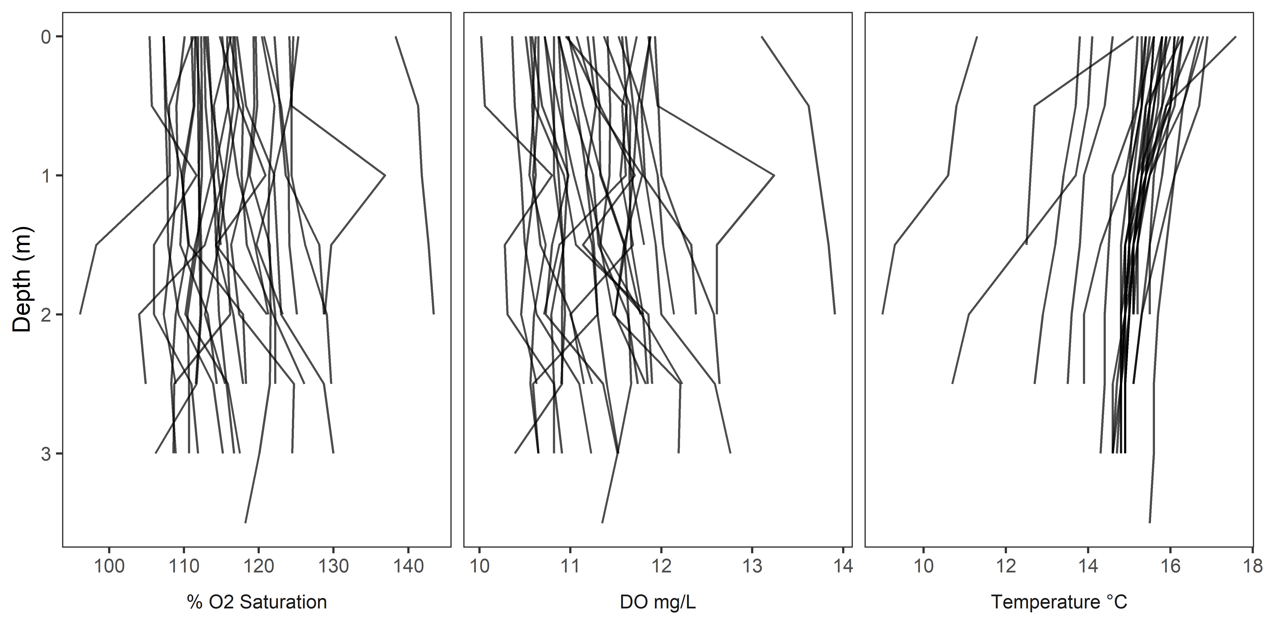

The highest DO readings were from the mouth separating the north and south basin. DO was lowest in the center of the main basin. For the below plot the left panel is the surface (depth = 0) and the benthic is the lowest reading.

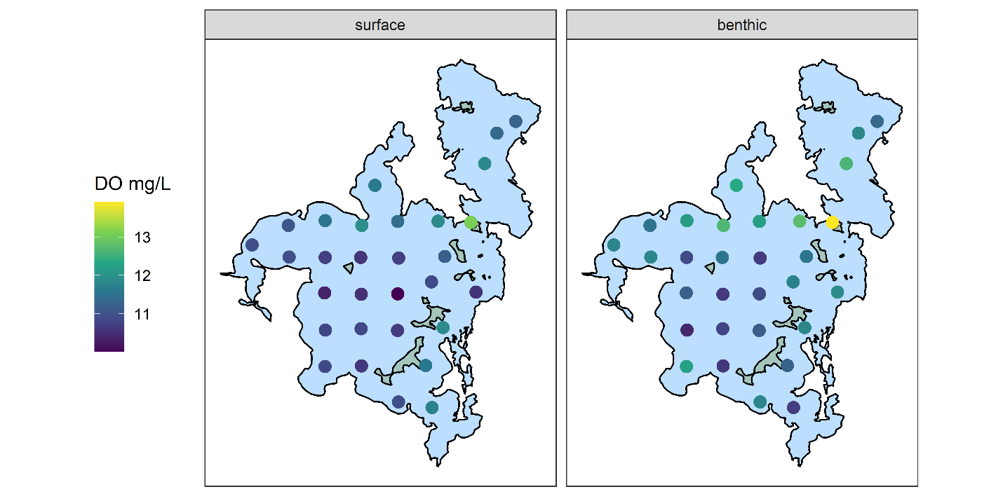

These DO profiles give a very rough sense of autotrophic structure. If DO increases with depth, it suggests that benthic production may exceed primary production. If DO decreases with depth, it suggests that the pelagic zone is a source of oxygen. This interpretation is flawed and should be treated with caution. To visualize this, I divided the difference in surface and benthic do by the average of the two values. Because temperature had a generally consistent negative trend with increasing depth, I did this both with concentration and % saturation. Higher values indicate a that surface DO exceeds benthic DO. Values near 0 are roughly in balance. Surprisingly, most spots had higher benthic DO than surface DO regardless of the metric. As expected, given the temperature trends, using concentration has more benthic dominated sites. Interestingly, the location by the cold springs had much higher surface than benthic dissolved oxygen, despite less phytoplankton and the Álftavogur site had higher benthic, despite the most phytoplankton. Álftavogur could be explained by the Cladophora mat.

For the moderate values (removing secchi of 0.8 and where it could be seen on the bottom), there perhaps a very weak negative trend in the autotrophic structure (as defined above) and secchi depth (p = 0.039). Why the two outliers show the opposite pattern is unclear to me. It all might be noise. The below plots are the same; The top plots show all data (with the secchi at the bottom, scored as 4); the bottom plots remove these two sites.

### Midges

One of my interests in this sampling event was to determine 1) are there any *Tanytarsus*? And 2) where are they? The timing may be suboptimal to clearly address this question. Early August sometimes corresponds to the *Tanytarsus* emergence, and we did observe a small, localized *T. gracilentus* swarm on 10 August at Kálfaströnd. However, we usually see second and third instar *Tanytarsus* at this time in our routine data, the summer emergence appears to be less discrete than the spring generation in our emergence traps, and the unusual warm and sunny weather we observed this summer may alter the emergence timing in unpredictable ways. Regardless, this should be treated with some caution.

We took a single core at each of the 30 locations and processed them in the standard way for midges. We sieved the top 1.5 cm through 63-μm mesh. We sieved the remainder of the core 125-μm mesh. We transferred all midges into ethanol. Once in ethanol, we identified them to subfamily (Orthocladiinae and Tanypodinae) and tribe for the Chironominae (Tanytarsini and Chironomini). We also counted *Tubifex sp*. (which are not midges but are moderately common detritivores in the benthos). We measured the head capsule width to determine the instar of the midges.

The lake had few midges in comparison with what we have seen in the past 7+ years. We found 5 Tanytarsini, primarily in the bay by Vindbelgjarfjall, although we did find one individual in the bay by Kálfaströnd. Of course, these need to be mounted and identified to species to determine if they are indeed *T. gracilentus* and not other Tanytarsini. Chironomini were the most abundant taxon. We found 52 individuals total and they were found in the highest abundance in the center of the main basin. Despite being the most numerous, these densities were still quite low for Mývatn. Orthoclades were found in low abundances in a handful of locations. These locations included a Cladophora mat, two areas dominated by macrophytes, and one bare sediment (although this location is very near lots of macrophytes). Tanypodines also appeared most common along the lake edge.

These species-specific patterns resulted in the midge communities in the center of the lake being dominated by the Chironomini and the edges were more diverse. There were 3 locations where no midges were found – off the southern edge of Miklay, in the dredged area by Reykjahlid, and along the southwestern edge of the lake, just north of Álftavogur.

Using our long-term data, we could determine the instar of the Tanytarsini and Chironomini. Most of the Tanytarsini we found were second instar. One individual was a third instar. At this stage they are predicted to be less mobile than the first instar, so perhaps this is where they have settled. Presumably they are the spring 2022 generation and not the summer 2021 generation (if this delineation is at all meaningful for last summer). The Chironomini included individuals in the second, third, and fourth instars. There may be meaningful patterns in Chironomini stage structure.

## Benthic Algal communities

In addition to the midge core, we took a core which we measured using a benthotorch. This estimated the composition of the algal community on the surface layer. In general, the benthos was characterized by diatoms. We did not observe any green algae on the benthic surface using the benthotorch. For Cladophora mats, these may be covered in *Epithemia*, which would be read by the benthotorch. Total algal abundances were highest in the east basin and near the outlet.

### Benthic-Pelagic Algal interactions

Because we have paired water column and sediment benthotorch readings, I just wanted to take a brief look at the correlation between benthic and pelagic algal taxa. I used the spearman rank correlation. There appears to be a negative association between the rank order of pelagic cyanobacteria and diatoms. Interesting. There is also a moderately strong correlation between sediment diatoms and cyanobacteria. Perhaps unsurprisingly, there are no obvious correlations in benthic and pelagic algal taxa.

### Zooplankton

At each of the locations, we filtered 2 L of water through 20-μm mesh. This retained phytoplankton and zooplankton. We have identified the zooplankton from the first 11 sample locations. Rotifers are the most numerous group of zooplankton. *Filinia* was the most common rotifer, followed by *Keratella*. One location by the outlet had over 300 *Daphnia*, but that was not true of its neighbors. Nauplii generally were the most common non-rotifer. *Cyclops* were also found at moderately high abundance at the north side of the outlet. *Chydorus sphaericus* were found to represent more than a third of non-rotifers at the Álftavogur site.

A very simple look at the communities shows no relationship between distance and community similarity.

## Unanalyzed samples

There are several sources of data that we have not yet analyzed.

### Nutrients

At each location, we took nutrient samples of the interstitial water and of the water column. Both were filtered through 0.45μm syringe filters prior to freezing. Árni has these samples and plans to send them to Sweden to be analyzed with the other monitoring data. The interstitial nutrients come from the same cores that we took benthotorch readings on.

### Midges

Midges have been identified roughly to subfamily/tribe. However, mounting larvae of some taxa (Tanytarsini) is essential and identifying all groups to species could be interesting. This may be more work than it is worth.

### Spectra

The timing of this sampling event was within 3 days of the NASA AVARIS flight (9 August 2021), which pointed a hyperspectral camera at the lake. As described in Phytoplankton: Benthotorch readings on Whatman filters, we filtered 300 mL of water on Whatman filters and froze them. These fit perfectly with Phils spectrometer, and he thought it may be interesting to measure spectra on these. We have samples from station 33 which we can use to calibrate the spectra for chlorophyll and zooplankton but counting zooplankton or identifying phytoplankton might be worthwhile.

### Phytoplankton

As described in Zooplankton, we sieved 2L of water from each location through 20 micron mesh (the same samples as the zooplankton). These contain both zooplankton and phytoplankton. The algal communities could be identified either qualitatively or quantitatively.

### Zooplankton

We have not analyzed all of the zooplankton and plan to evaluate how useful this will be based on the first 11 samples.